**INTELLIGENT TRAFFIC CONTROL SYSTEM**

Srinidhi Rachavelpula*, Amit Rajendran**

*(Department of Computer Science, Amity University, Mumbai

Email: srinirachavelpula@gmail.com)

** (Department of Mechanical Engineering, Himalaya University, Itanagar

Email : amitraj094@gmail.com)

ABSTRACT

In India, bad traffic management has led to traffic congestion problems which is giving a negative impact on the economy and the quality of life. Also, people in India usually break rules which leads to collision that end up ultimately in accidents and also becomes a factor for traffic congestion. Hence, to eradicate this and manage the traffic efficiently. A new system is introduced which can be coupled with the existing traffic system that can help in controlling the problem. This new technology uses the concept of internet of things and servo motors to handle the traffic as per the traffic lights. This technology will help in making the city a smart city enhancing the quality of life.

***Keywords*** **–** traffic, traffic management, smart city, IOT, intelligent traffic control system, traffic control.

1. **INTRODUCTION**

A city is a complex system with hustle-bustle leading to traffic congestion. This idea of project is purely based on day to day experience of travelling through road. We face traffic congestion frequently in a day. Now, the question is what the reasons are for this traffic congestion? The reasons are 1) tendency to break traffic law due to lack of patience and emergency ,well in that case every rider or driver is in hurry in India.2)Increasing population is leading to increase in the no. of vehicles on the road.3)Breaking the signal also leads to mishaps like collision with opposite vehicle. Therefore, it has been determined that active traffic management is required. In most countries, traffic is managed by fixed-time signals, and in large cities in some developed countries, traffic is centrally controlled system. It can be determined that the current traffic management systems are centralized so far. Such systems can crash if there is a network problem. In addition, there is less concern about traffic flow fluctuations. Therefore, the proposed system manages traffic on local and centralized servers by simultaneously utilizing the concepts of the Internet of Things. In this we use Double Arm Traffic Barrier system to stop the vehicle from crossing the line and also the surveillance camera for operating the traffic density . In addition, this may also be helpful for future plans.

The rest of this article is divided into four parts. The Section II discusses the latest technology. The proposed system will be presented and discussed in Section III, and Section IV concludes and summarizes the research.

# **Literature review**

1.An intelligent traffic management system, partially deployed in Cambridge, with a queue detector buried in the road to detect traffic queues and notify the central control unit to make appropriate decisions. Since the system is centralized, it may be slow due to network problems. Researchers use surveillance cameras to detect traffic and use OCR to identify vehicles by license plate recognition. This is a simple method of detection, but the system will fail in India because of the wide variety of traffic, including bicycles, and no license plates. Car [1].

2.Osman and so on proposed a system in which they used a surveillance camera to detect traffic density using MATLAB, a flow controller and a wireless transmitter, which was used to send an image to the server after calculating the traffic density using the image of each part. The system uses a fixed (predefined) threshold that depends on the number of vehicles on the road. An algorithm is used to set the time span of the red light for a particular lane of the intersection, which is determined by the traffic density on the road and forwarded to the microcontroller, and then forwarded to the server [2].

3.Jadhav et al. Use surveillance cameras, MATLAB and KEIL (microcontroller coding) to control traffic congestion. This article also discusses priority-based permits and red Signal agent (license plate detection). Due to the use of bulky hardware, it is difficult to manage and becomes expensive.[3]

4.Swathi et al. An intelligent traffic routing system is proposed, which selects the shortest path with the least congestion. Sensors are used to collect data on traffic density, which uses solar energy and batteries. The sensor is always emitting infrared light, and when the objects are close, they detect the traffic density by monitoring the light reflected by the vehicle. However, readings may vary with temperature and humidity.[4]

# **Methodology**

3.1BACKGROUND

3.1.1 A Servo Motor is an actuator that allows for precise control of angular or linear position, velocity and acceleration. It consists of a suitable motor coupled to a sensor for position feedback. It also requires a relatively sophisticated controller, often a dedicated module designed specifically for use with servomotors. A servomotor is a closed-loop servo mechanism that uses position feedback to control its motion and final position. The input to its control is a signal (either analogue or digital) representing the position commanded for the output shaft.

3.1.2 NodeMCU is an open source IOT platform. It includes firmware which runs on the ESP8266 Wi-Fi from Espressif Systems, and hardware which is based on the ESP-12 module. It is a single mode microcontroller.

3.1.3 A breadboard is a solderless device for temporary prototype with electronics and test circuit designs. Most electronic components in electronic circuits can be interconnected by inserting their leads or terminals into the holes and then making connections through wires where appropriate.

3.1.4 A light-emitting diode (LED) is a semiconductor light source that emits light when current flows through it. Electrons in the semiconductor recombine with electron holes, releasing energy in the form of photons. We are using three colors of LED’s i.e. green, red and orange for the operation of traffic signals.

3.1.5 Connecting wires allows an electrical current to travel from one point on a circuit to another because electricity needs a medium through which it can move. Most of the connecting wires are made up of copper or aluminum. Copper is cheap and good conductivity.

3.1.6 Arduino is an open-source hardware and software company, and user community that designs and manufactures single-board microcontrollers and microcontroller kits for building digital devices. Using Arduino, we have programmed the NodeMCU.

3.2 SYSTEM OVERVIEW

Fig: 1 Block Diagram of Intelligent Traffic Control System

The proposed system represented in the Fig 1 is used to control the traffic congestion, avoid breaking of rules and accidents. The NodeMCU works as per the code that is built into it. The code has been written in Arduino platform. The status of the roads can be monitored in the control room and also on the mobile platform using the IP address.

The NodeMCU is used to regulate the traffic lights as well as the servo motors. The servo motors have been set at different angles. They rotate according to the status of the traffic light handling the traffic. The servo motors are connected to the traffic gates which act as barriers that will prevent people from breaking traffic rules and also control traffic congestion.

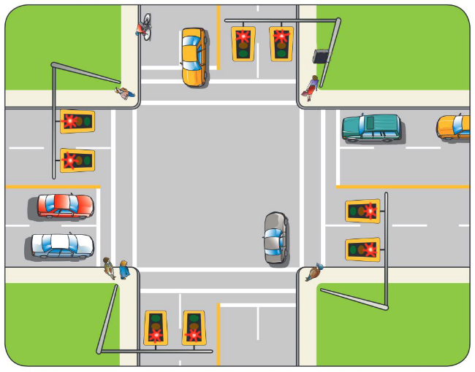

Fig: 2 Scenario

To understand the system, let’s consider a scenario as represented in Fig 2. We have considered a four-lane road junction. The system has been set up at all the outward road paths and the traffic signals are also been set up. The signals change in every 60 seconds and the servo motors rotate accordingly changing the position of the traffic gates which allows the movement of the vehicles. When the signal is green the traffic gate is completely lifted allowing the vehicles to move in all other three directions. After 60 seconds the signal turns orange and the traffic gate is at a different angle signaling vehicles to slow down. When the signal is red, the traffic gate completely closes. The signals on the rest three roads work cordially with each other eradicating traffic congestion. The status of these lanes can be seen or observed on the mobile platform through the IP address. In case of High traffic Density in any lane, the traffic police Operator can do the necessary settings in time delay between signals to avoid heavy traffic by observing the camera

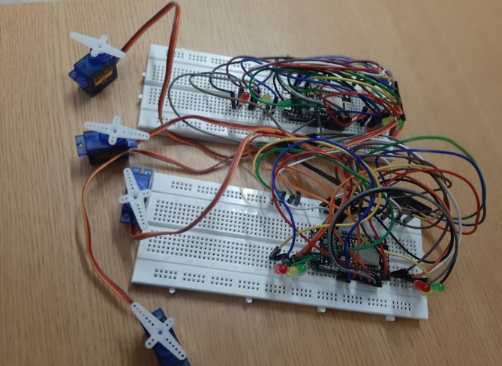

Fig 3: The IOT System

The intelligent traffic system is built is represents in Fig 3. As we have considered a four-lane junction to explain the system, we can see four servo operators. The traffic gates are attached to the arms of the servo motors that are going to act as the traffic barriers. The system is constructed on the breadboard and even the traffic signals can be seen on it. The connections are made from the NodeMCU to the traffic signals and also to the Servo motors. The action of the servo motors is dependent on the traffic signals.

# **RESULTS AND DISCUSSIONS**

Once the traffic density exceeds the specified threshold on the road, the system stops normal operation and keeps the green light on until the condition on the road returns to normal. Real-time data is also sent to local and central servers. n addition, a web interface was developed for the authorities to show them traffic statistics on the road so they can make real-time and future decisions as discussed.

# **CONCLUSION**

This research provides an effective solution for the rapid growth of traffic flow, especially in large cities, where traffic is growing and traditional systems are limited by the inability to effectively manage current traffic. Considering the latest method of traffic management system, an intelligent traffic A close up of a bridge

Fig 4: The traffic gates

management system is proposed to control road traffic conditions more effectively. It intelligently changes signal timing based on traffic density at a particular roadside and communicates with local servers to regulate traffic more efficiently than ever before. Even if the local server or centralized server crashes, the decentralized approach allows it to be optimized and effective when the system is up and running.

In an emergency, the central server communicates with the nearest rescue department to provide timely personal safety. In addition, users can ask for future traffic levels on specific roads, thereby avoiding wasted traffic. The system also provides useful information to the parent organization that can be used for road planning to help optimize the use of resources.

# **References**

**Journal Papers:**

1. E. Leigh, "Advancing integrated and sustainable transport for the Cambridge region," *Smarter Cambridge Transport, 2017.*
2. T. e. a. Osman, "Intelligent traffic management system for a cross section of roads using computer vision," *in Computing and Communication Workshop and Conference (CCWC), 2017 IEEE 7th Annual, 2017.*
3. P. K. K. P. S. T. Prashant Jadhav, "Smart Traffic Control System Using Image Processing," *International Research Journal of Engineering and Technology (IRJET), vol. 3, no. 3, pp. 2395-0056, 2016.*
4. V. S. A. M. S. D. K. K. Swathi, "Traffic Density Control and Accident Indicator Using WSN," *International Journal for Modern Trends in Science and Technology, vol. 2, no. 4, pp. 2455-3778, 2016.*